**Coding Challenges**

Ques :1 Reverse the String without changing special character index

Input:T@stA

Output: t@sT

Ques 2: remove unwanted spaces from the String

Input: try to remove spaces

Output: try to remove spaces

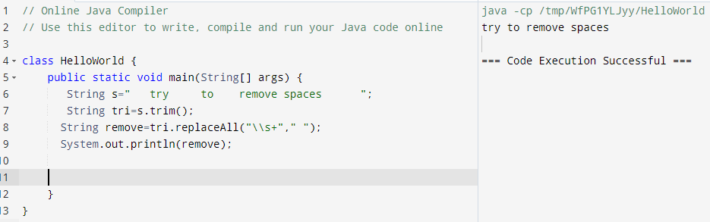

Ques 3: Remove Fist and last character from the string

Input: suresh

Output: ures

Hint: Remove last character then remove first character- Reason – after deleting first index, length will be changed.

Or

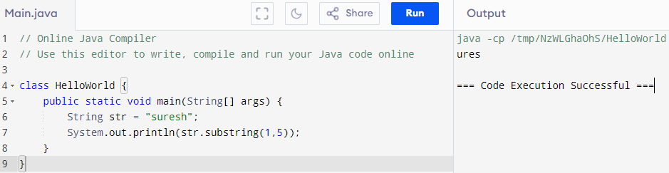

Ques 4: print sum of matching numbers

Input: num=8, a []={12,5,3,7,1,6,2}

Output: 5+3=8, 7+1=8, 6+2=8

Ques 5: Reverse String - index not changing

Input: Suresh Kasi

Output: hseruS isaK

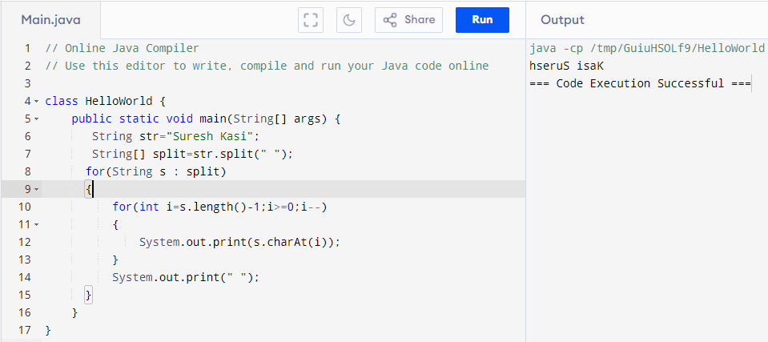

Ques 6: Reverse string

Input: Suresh Kasi

Output: isaK hseruS

Ques 7: Find Largest, Second, Third largest number in a array- without inbuild function

Input: {2,5,3,7,8,9,10}

Output: largest 10, second largest 9, third largest 8

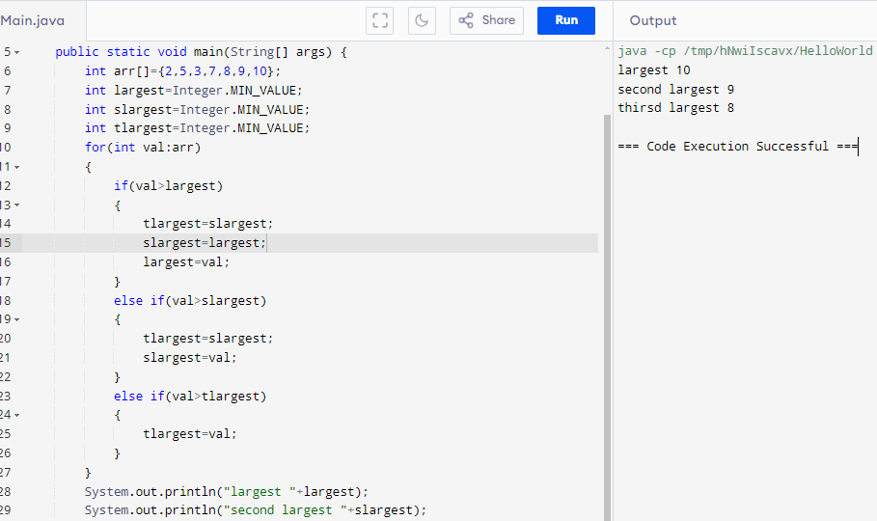

Or

Easy Way

Ques 8: Reverse Program also print small to upper and upper to small case

Input: Suresh Kasi

Output: ISAk HSERUs

